**1. Project Overview**

This project is focused on creating a **CRM Application for Laptop Rentals**, designed to address the challenges of managing rental processes, customer relationships, and operational inefficiencies. The goal is to deliver a comprehensive solution by leveraging Salesforce CRM’s capabilities. Through this project, we aim to enhance customer experience, optimize store operations, and improve overall efficiency, thereby supporting the long-term goals of ensuring streamlined operations and fostering better customer engagement.

**2. Objectives**

**Business Goals:**

* Streamline the laptop rental process to reduce operational overhead.
* Enhance customer relationship management to improve customer satisfaction and retention.
* Automate repetitive tasks to save time and resources.
* Provide actionable insights through reports and dashboards to aid decision-making.

**Specific Outcomes:**

* A centralized database for managing customer and rental information.
* Automated email communication with potential and existing customers.
* Real-time tracking of rental inventory and statuses.
* Creation of custom reports and dashboards to analyze customer engagement and business performance.

**3. Salesforce Key Features and Concepts Utilized**

* **Custom Objects:** Used for managing rental transactions and inventory details.
* **Workflows and Process Automation:** Automated email reminders for rental due dates and promotional campaigns.
* **Reports and Dashboards:** Provided insights into rental patterns, inventory status, and customer satisfaction.
* **Email Integration:** Facilitated communication with customers via personalized and automated email templates.
* **Role-Based Access Control:** Ensured data security by implementing profiles and permission sets for different users.

**4. Detailed Steps to Solution Design**

**Data Models:**

* Custom objects: “Laptop Inventory,” “Rentals,” and “Customers” to store all relevant information.
* Relationships: Defined lookup and master-detail relationships between objects for seamless data association.

**User Interface Designs:**

* Tailored page layouts for rental and customer records.
* Use of Lightning App Builder to create intuitive and efficient user experiences.

**Business Logic:**

* Apex triggers for custom automation.
* Validation rules to maintain data accuracy and consistency.

**Relevant Screenshots:** Include screenshots of custom objects, workflows, dashboards, and page layouts.

**5. Testing and Validation**

**Unit Testing:**

* Tested Apex classes and triggers to ensure accurate automation.
* Code coverage maintained above 75% as per Salesforce standards.

**User Interface Testing:**

* Verified the functionality of custom layouts, workflows, and dashboards.
* Conducted end-to-end testing for rental workflows, including inventory updates and email communications.

**6. Key Scenarios Addressed by Salesforce in the Implementation Project**

* **Automated Email Reminders:** Ensured timely communication with customers about rental due dates and new offers.
* **Inventory Management:** Allowed real-time updates to laptop availability, preventing double bookings.
* **Customer Engagement:** Enhanced interaction with customers through personalized emails and follow-ups.
* **Rental Tracking:** Provided visibility into rental statuses, including active, overdue, and completed transactions.
* **Operational Insights:** Offered detailed reports and dashboards for monitoring business performance and customer trends.

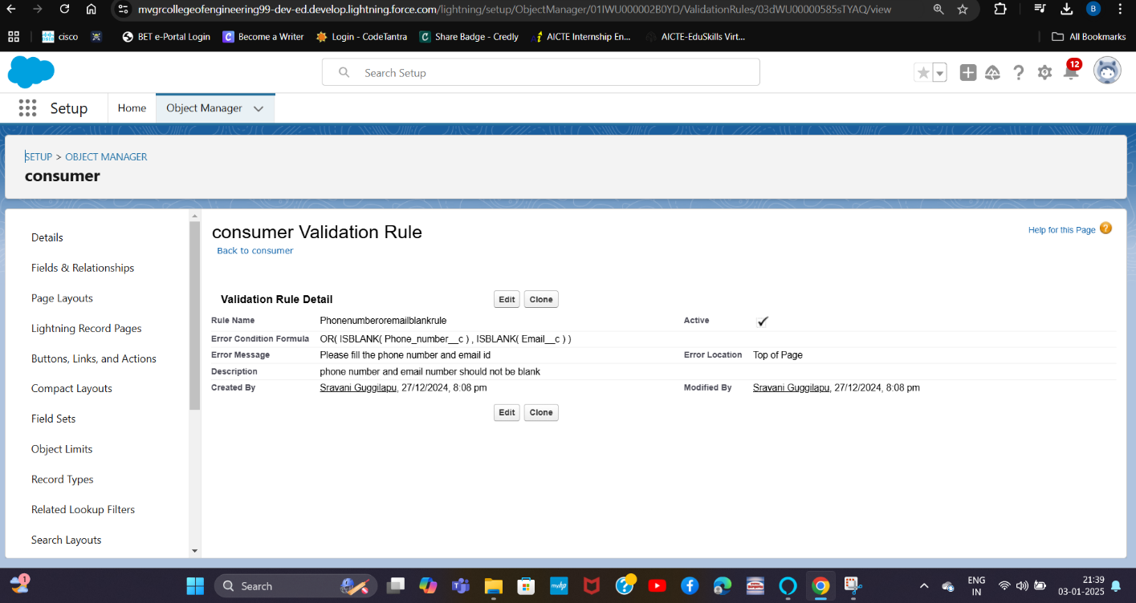**7.Screenshots**

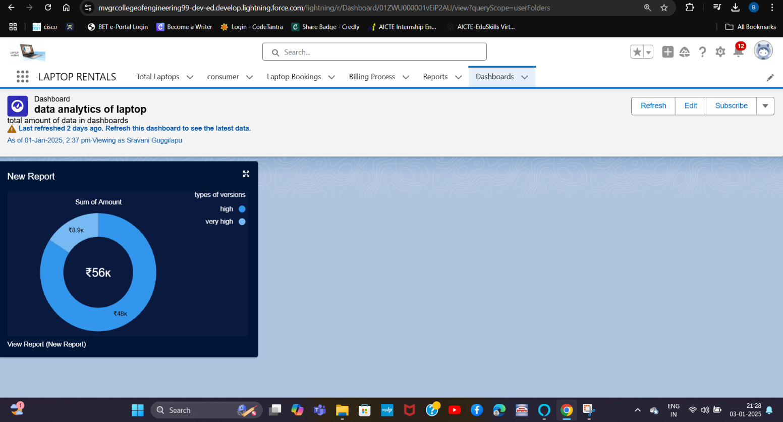

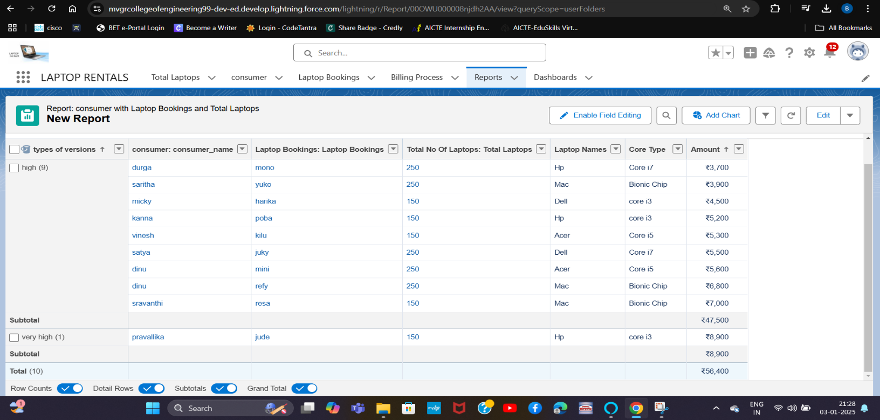 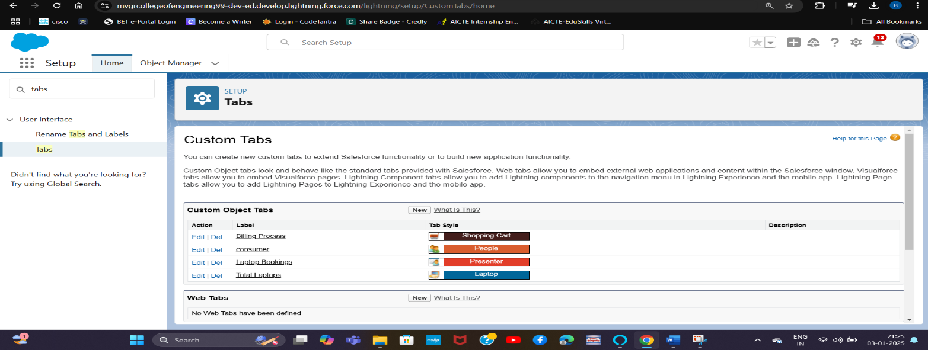

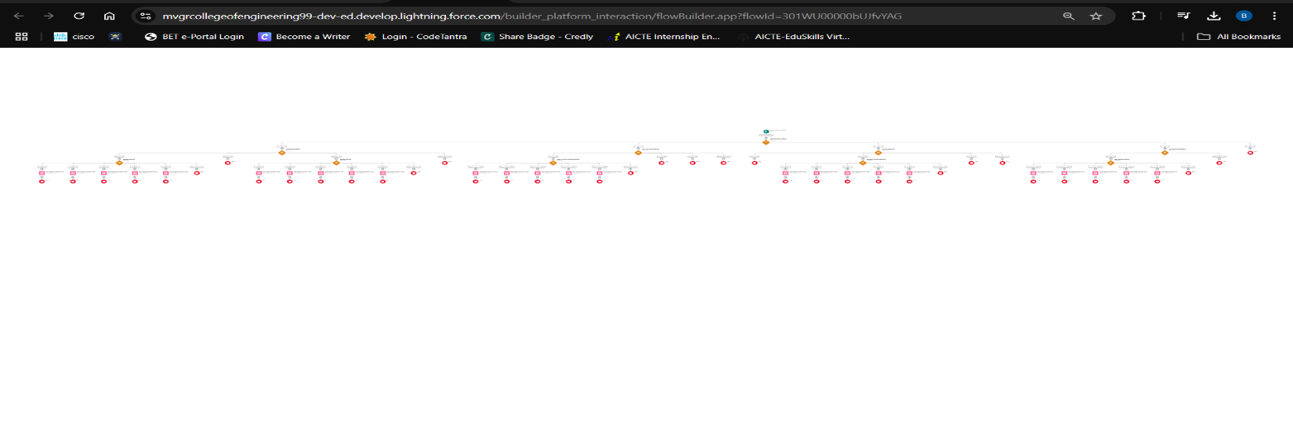

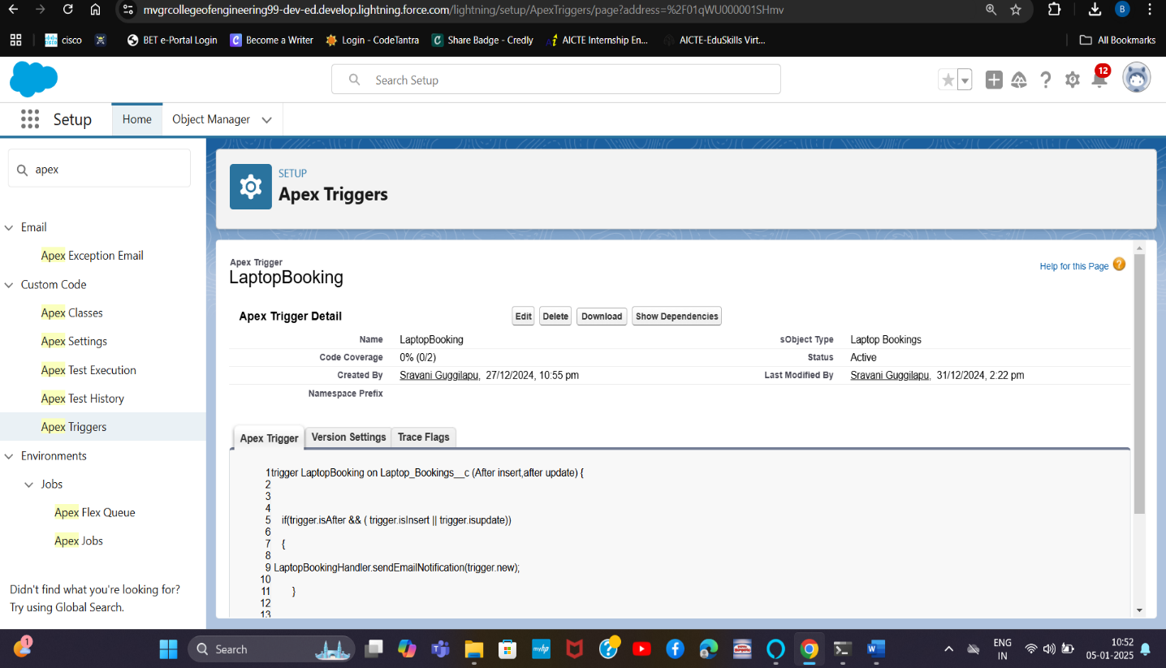

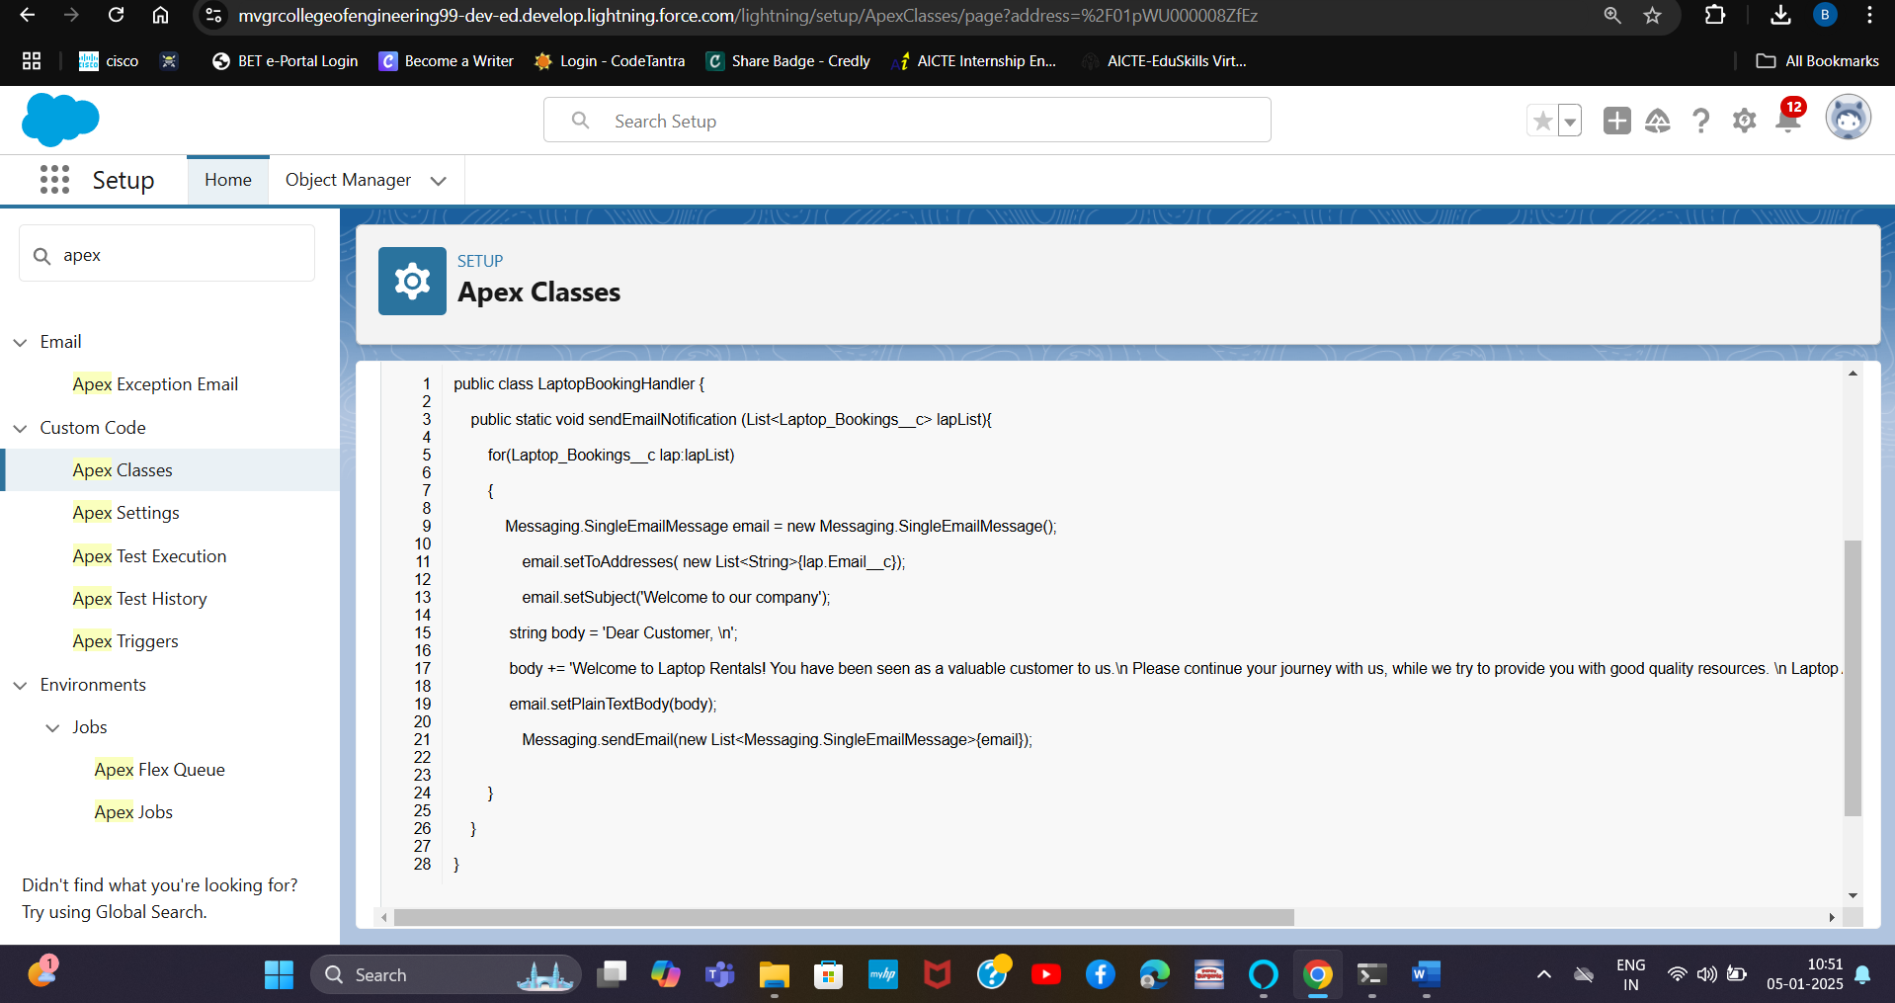

**8. Conclusion**

**Summary of Achievements:**  
The *CRM Application for Laptop Rentals* successfully addresses the challenges of managing rentals and customer relationships by implementing Salesforce CRM. Key achievements include the automation of email communication, optimization of inventory tracking, and generation of actionable insights through custom dashboards. These improvements have significantly enhanced customer satisfaction and operational efficiency, supporting long-term business growth.